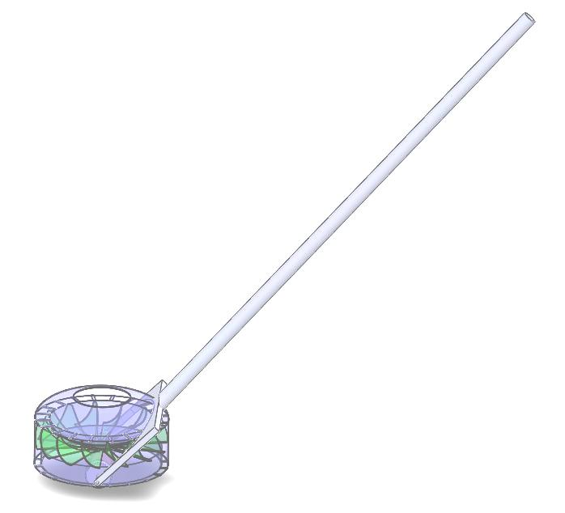
Push Powered Vacuum Cleaner
MENG 370 Design Project Report
Spring 2013 Semester

Date: 04/17/13
Group Leader: | Prosper Mogboruko
Group Member: | Rich Vo
 | Chris DeAngelis

Instructor: Professor Jong B. Lee, Ph.D.

Department of Mechanical Engineering
College of Engineering and Computer Science
New York Institute of Technology
Old Westbury, NY

ACKNOWLEDGEMENTS

We would like to express our gratitude to all those who gave us the possibility to complete this design term project.

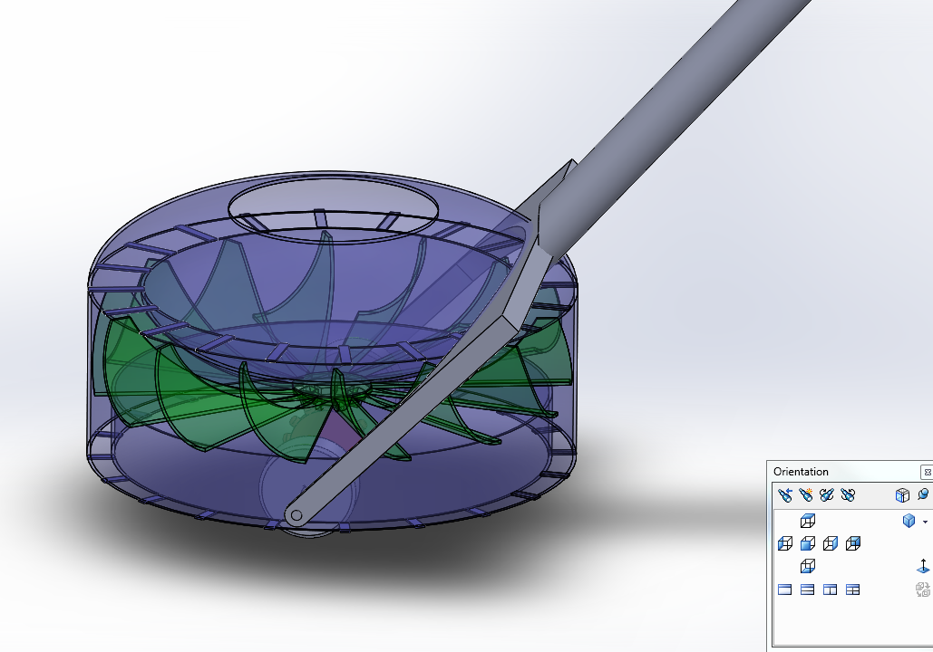Illustration 1: Current Solidworks Version. Outer shell is transparent by design.

TABLE OF CONTENTS

Summary | 4
Introduction | 6
Main section | 7
Final section | 12
Appendices | 16

Summary

When choosing a topic for our project we had to brainstorm many ideas. For each idea it was critical to define the “need” associated with that idea. The topic we chose to focus on for this project is a mechanically powered vacuum cleaner. The idea originated from Rich Vo's design of a device that transferred vertical rotation into high speed horizontal rotation. In essence the Mechanically Powered Vacuum Cleaner that we have designed puts Rich's idea into application.
This introduction will overview the sections of our final report on this design. These sections include why we chose to design a vacuum, what the mechanical vacuum is, how we designed the mechanical vacuum, and improvements that we made throughout the design process. Interestingly, in the early stages of our project a great deal of consideration went into what our machine was actually going to do. We considered dusting and polishing before deciding that the machine would act like a vacuum.
Another part of our project is our collaborative design efforts using Solidworks and GitHub. One of our goals was to create an exact 3D model of our final product using assembly. This allows each member of our team to create individual 3d parts and connect them all together in one file. We realized early on that it would be vital for us to all use the same software version so that we could make changes to each others work.
Furthermore, a mechanical analysis of the parts was completed in addition to a flow analysis in Solidworks. This section analyzes what external forces each part is subject to. This demonstrates the reason for some of our design features, and shows which parts may be designed for easy maintenance or replacement.
In addition to the 3D modeling of our design we put a great deal of consideration into materials for our project. The finished product has about 12 separate parts, but they will not all be the same material. For example, the wheels should be a type of rubber that has a balance between hardness, traction and cost. Another example is the handle which might be a plastic that has a good balance of hardness, cost and weight. There may even be metallic components in our design. All of this is covered in the main section, including our rational for all of these decisions.
Another section we added to our report is the manufacturing process for our product. This details the instructions of how to fabricate our product. By considering how our project will be fabricated we can improve our design by streamlining parts, and simplifying components.
Finally, our paper includes specifications of the final product. This section outline the abilities and limitations of the Push Powered Vacuum. Also, the estimated weight, size and capacity. Some limitations may be particle size and weight that can be vacuumed using our product. For example the distance between fan blades may limit the particle size that can be vacuumed.
Introduction
When we started the brainstorm process we considered many different possible projects. The idea we kept coming back to was transforming vertical rotation into horizontal rotation. We realized that by combing this idea with a push powered device we could create a horizontal disk that would rotate. Illustration 1 (bellow) is the earliest sketch of our concept.
Originally, we were unsure whether the device would sweep, polish or something else. We settled on the idea of changing the large disk with a fan, which created an upward suction. See the Illustration bellow.
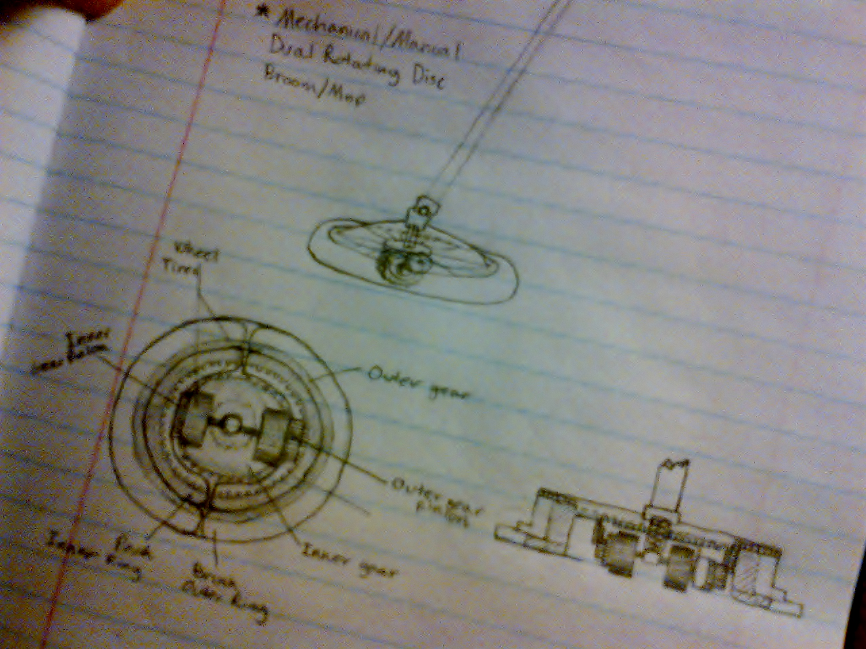Illustration 2: Original Concept Sketch, by Rich Vo
Main Section
As you can see once we decided that the design would be a vacuum cleaner, we needed a compartment to store the dust and dirt particles. This early 3d model was the next revelation in our design process and it incorporates a “dual dust bin compartment” the green donut shaped section.
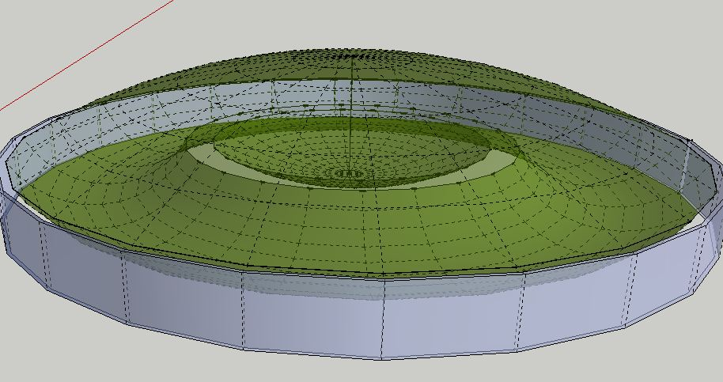Illustration 3: First 3D model, created with Sketchup
In order to make this work, the fan needed to be bellow the green dust compartment. Additionally, the fan was becoming highly customized, which would have led to costly manufacturing challenges.
Furthermore, the fan radius was greatly reduced by this design. We believed that this low radius would have led to a lower fan speed, which would have reduced overall suction. So of course, there were many problems with this version.
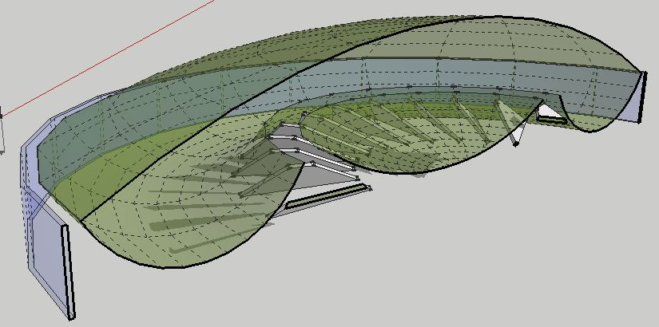Illustration 4: Cross section of the early design.
However, the act of creating the model forced us to acknowledge these design issues and brainstorm solutions and improvements. Without these early mistakes, or final product would never have been as good as it is now.

At this point in the project we made the move from Google Sketchup to Solidworks. We felt that the model was beginning to become more and more complicated, and if we didn’t convert soon, there would be too much legacy with the Sketchup program.
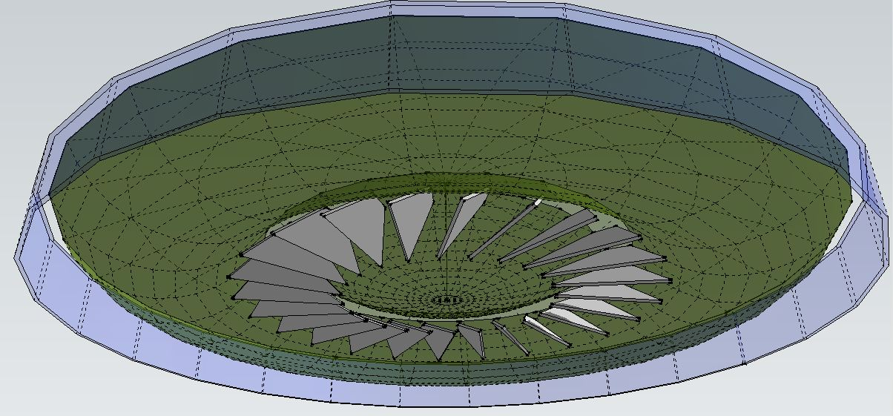Illustration 5: A bottom view of the second version, the gray trapezoids are
actually the concept fan for this early version.
Also, we knew that Solidworks would enable us to do much more professional flow and stress analysis. Above all else, Solidworks would allow us to assemble individual parts.

As you can see, once we migrated to Solidworks, problems with the fan immediately began to surface. However, other parts like the chassis, wheels and axle began to fit nicely together and take on shape.
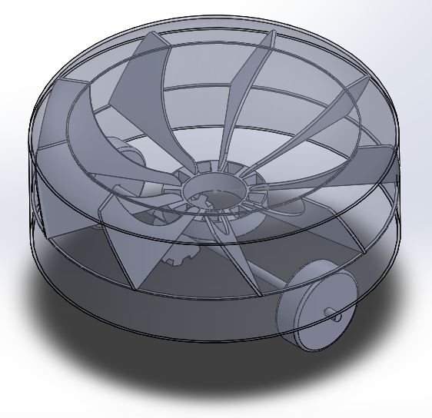Illustration 6: An isometric view of the first Solidworks model.
Above it can also be seen that we realized a need for a larger diameter fan. Hence a much higher moment of inertia, and more lift. However, due to logistics, the vertical profile had to be increased creating a less sleek, but more effective design.

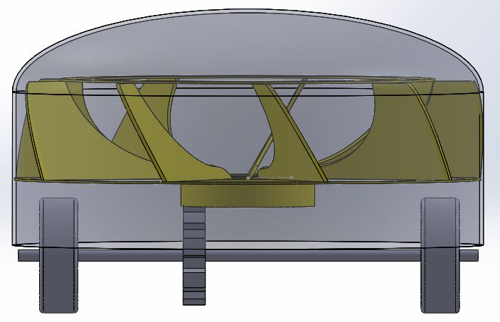Illustration 7: A frontal profile of the third version. The dimensions are becoming more realistic. Also, the gear ratio can be seen very well here. The diameter of the wheels limit the gear diameter. However, by positioning the gear in the center of the axle we generate a higher gear ratio for the outer fan blades.

Final Section
At this point we stepped back and began to discuss manufacturing aspects of the design. Rather than using a highly customized fan like the one above, we realized that it would be more realistic and cost effective to use a more available fan design which would be cheaper and easier for construction.
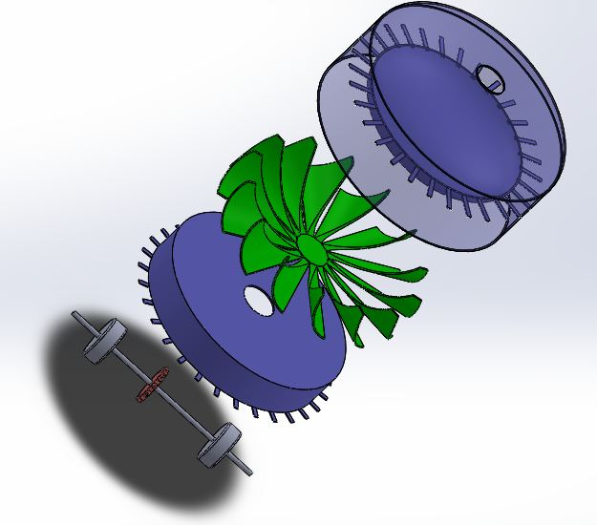Illustration 8: An assembly diagram using Solidworks. The blue teeth are actually just supports, they have not rotational or gear like purpose. Additionally, by using part design and assembly the model became much less cumbersome to work with.
As you can see bellow, we maintained very much of the original design (Illustration 1).
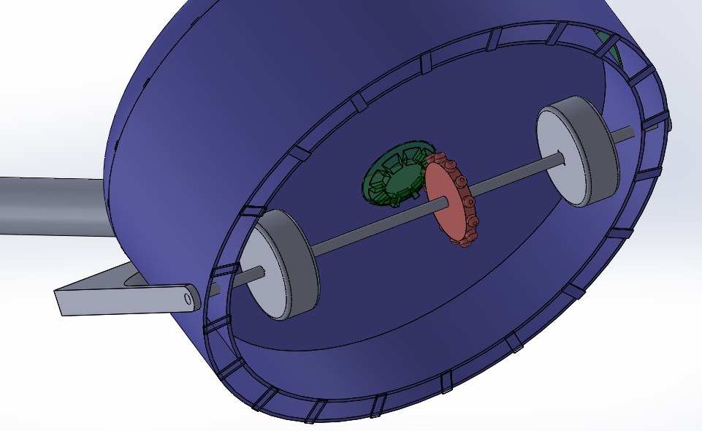Illustration 9: The handle attaches to the main axle, this limits stress on the main body. Also, this generates more traction for the rubber wheels.
We also have added a flow shield to the bottom, this focuses all of the vacuum suction to the perimeter of the device. Creating much higher pressure differentials.
Using Solidworks we are improving the design, and minimizing inefficiencies.
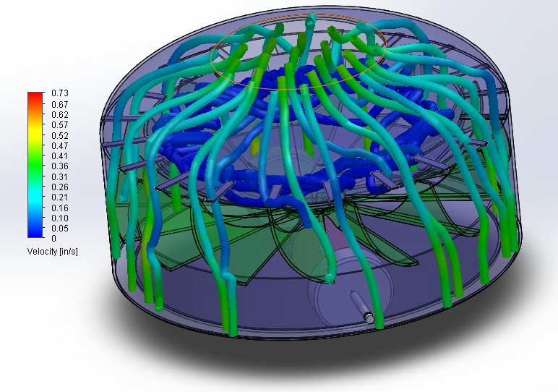Illustration 10: Solidworks flow analysis, by Chris DeAngelis
We think the dark blue lines are beautiful, and were very happy to see them. They indicate that the wind-speed in the dust collector will be almost 0, which is exactly what we want. This will allow the particles to settle until they are removed by the end user.
This simulation has given our project a huge boost, by demonstrating how our final product may actually work!

Bibliography
1. References
Booth , Cecil H. "Invention of the vacuum cleaner." Invention of the vacuum cleaner. February 20, 2008.
Bissell, M. “Carpet Sweeper Patent”. www.google.com/patents/US391129

2. Bibliography
Dan, Lockney. USA. NASA. Improving Vacuum Cleaners. John Jones, MAY 1, 2011. http://spinoff.nasa.gov/spinoff1997/ch9.html
Booth, Cecil. ""The origin of the vacuum cleaner," 15. 1934–1935. http://en.wikipedia.org/wiki/Vacuum_cleaner
Tom , Harris. "How Vacuum Cleaners Work." howstuffworks. N.p. 13 Mar 2013.
http://home.howstuffworks.com/vacuum-cleaner5.htm
Illustration 11: Current Solidworks Version. Outer shell is transparent by design.

